

Wallet Walkthrough – Hands-on Wallet Setup   
  
**Objective/Aim:**



To understand the process of setting up a blockchain wallet (cryptocurrency wallet) practically, exploring its role in key management, transaction signing, and secure interaction with blockchain networks.

**Apparatus/Software Used:**

Laptop

MetaMask Wallet

Browser Extension

Ethereum testnet

Testnet Faucet

Blockchain explorer

**Theory/Concept:**

**What is a Blockchain wallets?**

A **blockchain wallet** is a digital tool that allows users to store, send, and receive cryptocurrencies securely.

Wallets are of two types:

* **Hot Wallets** – Connected to the internet (e.g., MetaMask, Trust Wallet).
* **Cold Wallets** – Offline wallets (e.g., hardware wallets like Ledger, Trezor).

**Public Key** – Works like an account number; shared to receive funds.

**Private Key** – A secret cryptographic key used to sign transactions; must never be shared.

**Seed Phrase / Recovery Phrase** – A human-readable backup (12–24 words) that can regenerate wallet keys

**Functionality**:

* Key pair generation (public/private)
* Address creation
* Transaction signing
* Balance tracking via blockchain explorers

**Use Cases**: Cryptocurrency storage, DeFi apps, NFTs, staking, and secure blockchain interactions.



**Procedure:**

* Step 1: Install metamask browser extension.
* Step 2: Create a New Wallet.
* Step 3: Secure Seed Phrase and Password Setup
* Step 4:Network Selection
* Step 5: Fund wallet
* Step 6: Transaction Execution.

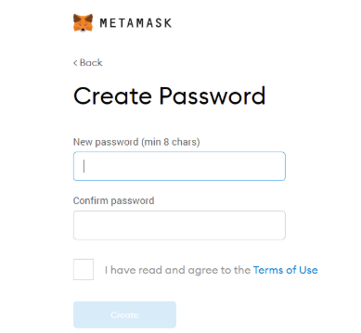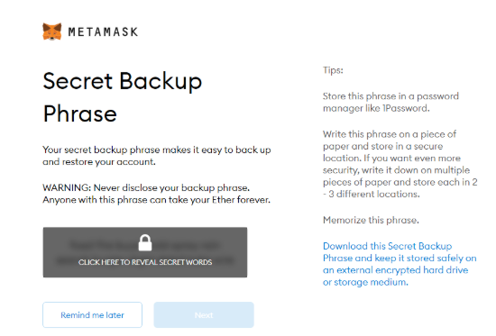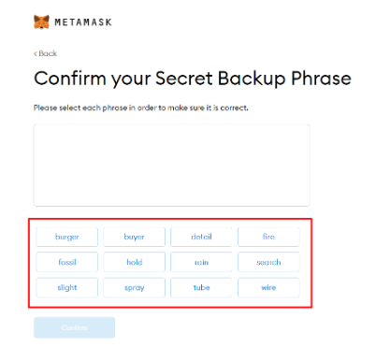

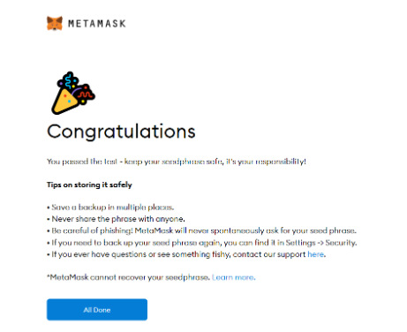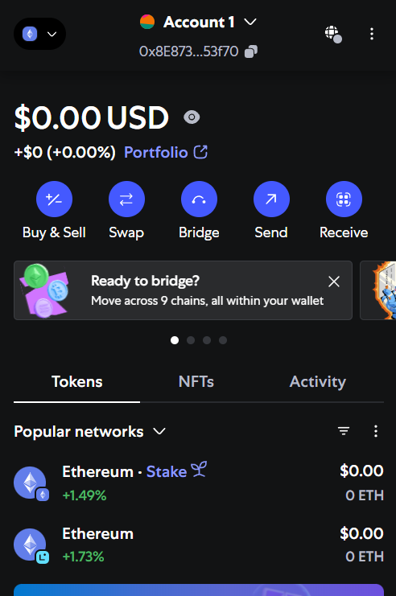

**Observation :-**

* MetaMask wallet installed successfully.
* New wallet created with a strong password.
* 12-word seed phrase generated and backed up securely.
* Private key remains confidential, not to be shared.
* Unique public address assigned for transactions.
* Test transaction completed and verified on blockchain explorer.



|  |  |  |  |
| --- | --- | --- | --- |
|  |  |  |  |
|  |  | nbvnvnvx |  |
|  |  |  |  |
|  |  |  |  |
|  |  |  |  |
|  |  |  |  |
|  |  |  |  |